

## PROJECT ON:

## PLACEMENT MANGEMENT SYSTEM

EDUSITE

Submitted By,

**GEETHA R SOMANI**

**BE**

**Batch**: 5889-2021

**Center**: Bangalore

Technical Trainer,

**MAMTA BOGA**

**EduBridge**

(School of coding)

# TABLE OF CONTENT

|  |  |
| --- | --- |
| CONTENT | PAGE NO |
| INTRODUCTION | 3 |
| TECHNOLOGIES | 4 |
| TOOLS USED | 5 |
| METHOLOGY | 6 |
| RESULT | 7-11 |
| CONCLUSION | 12 |

# INTRODUCTION:

The Placement Management System is developed as an attempt to take a record of company and students by restricting such a large database to that of a particular class of students or company. The system is a web application that can be accessed throughout the organization with proper login provided. The key feature of this project is that it is a onetime registration. Our project provides the facility of maintaining the details of the students. This will also help in fast access procedures in placement related activities.

Our Project Include Modules:-

* AdminModule
* Student Module

1) Admin

* Admin can ADD/VIEW/UPDATE/DELETE Company.
* Admin can ADD/VIEW/UPDATE/DELETE Jobs.
* Admin can VIEW Students registered.

2) Students

* Students can VIEW Companies.
* Students can VIEW the Jobs by the company.
* Students can apply for Jobs.

**Software Requirements:**

**Front end**: Java, HTML, CSS, JavaScript, Bootstrap.

**Backend**: Spring-boot, MySQLworkbench8.0.23CE.

**Middleware/Server**: Eclipse IDE for Java EEDevelopers

**Browser**: Best result on Google Chrome

**Operating System**: Window10.

**\*\*\***

# TECHNOLOGIES USED

HTML:

(Hypertext Markup Language) is the code that is used to structure a web page and its content.

For example, content could be structured within a set of paragraphs, a list of bulleted points, or using images and data tables.

CSS:

Cascading Style Sheets (CSS) is a stylesheet language used to describe the presentation of a document written in HTML or XML (including XML dialects such as SVG, MathML or XHTML).

CSS describes how elements should be rendered on screen, on paper, in speech, or on other media.

BOOTSTRAP:

Bootstrap is an HTML, CSS & JS Library that focuses on simplifying the development of informative web pages (as opposed to web apps).

The primary purpose of adding it to a web project is to apply Bootstrap's choices of color, size, font and layout to that project.

JAVA:

Java is used as the server-side language for most back-end development projects, including those involving big data and Android development.

Java is also commonly used for desktop computing, other mobile computing, games, and numerical computing.

SPRING BOOT:

Java Spring Boot (Spring Boot) is a tool that makes developing web application and microservices with Spring Framework faster and easier through three core capabilities, Autoconfiguration.

**\*\*\***

# TOOLS USED

*ECLIPSE:*

* Eclipse is an integrated development environment used in computer programming.
* It contains a base workspace and an extensible plug-in system for customizing the environment.

*MYSQL:*

* MySQL is a relational database management system based on SQL – Structured Query Language.
* The application is used for a wide range of purposes, including data warehousing, e-commerce, and logging applications.
* The most common use for mySQL however, is for the purpose of a web database.

**\*\*\***

# METHOLOGY

The system contains 2 modules as admin login student login. Each module has the same login page. The login page has a login id and password field. By entering values in that field users should log in to the system. A profile for student is created , if not then they register with the necessary credentials for the portal. The system uses MySQL for database management and will sort the data. If student are interested to attend that particular drive can apply for it. Admin has authority to access student details, add new drives and new company information.

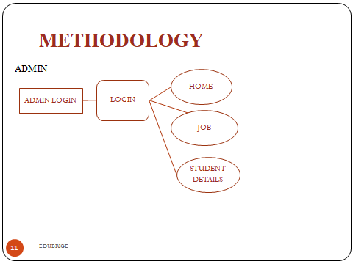

# RESULT

The login page of the placement management system is shown in the Figures. The student and admin can login to the system by using this login form.

FIG 1: HOME PAGE

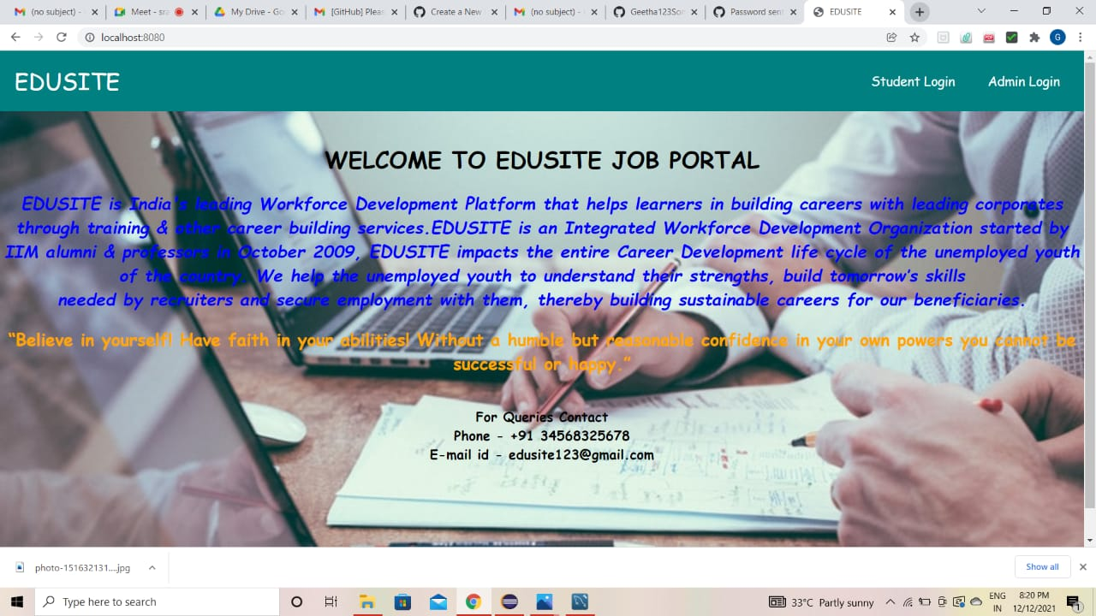

FIG 2: ADMIN PAGE

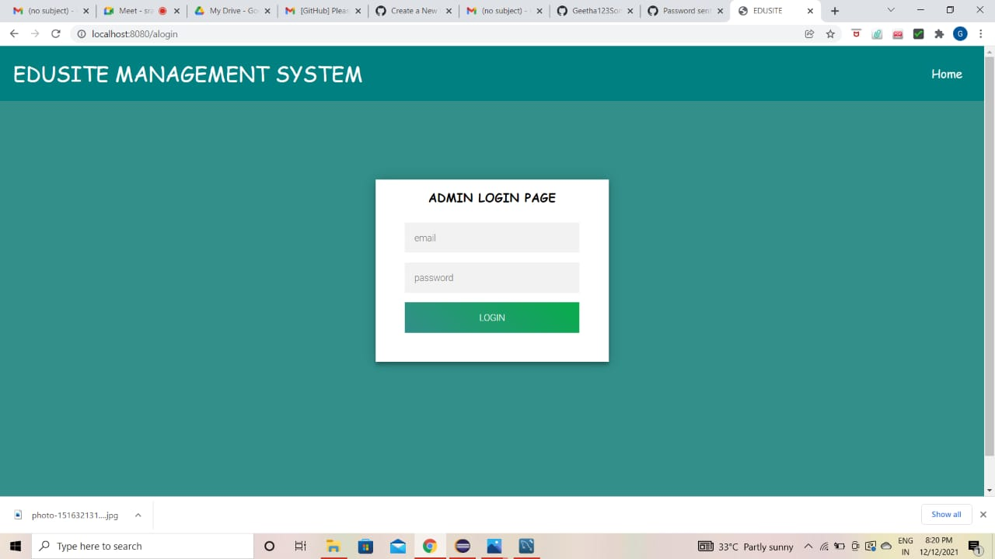

FIG 3: STUDENT PAGE

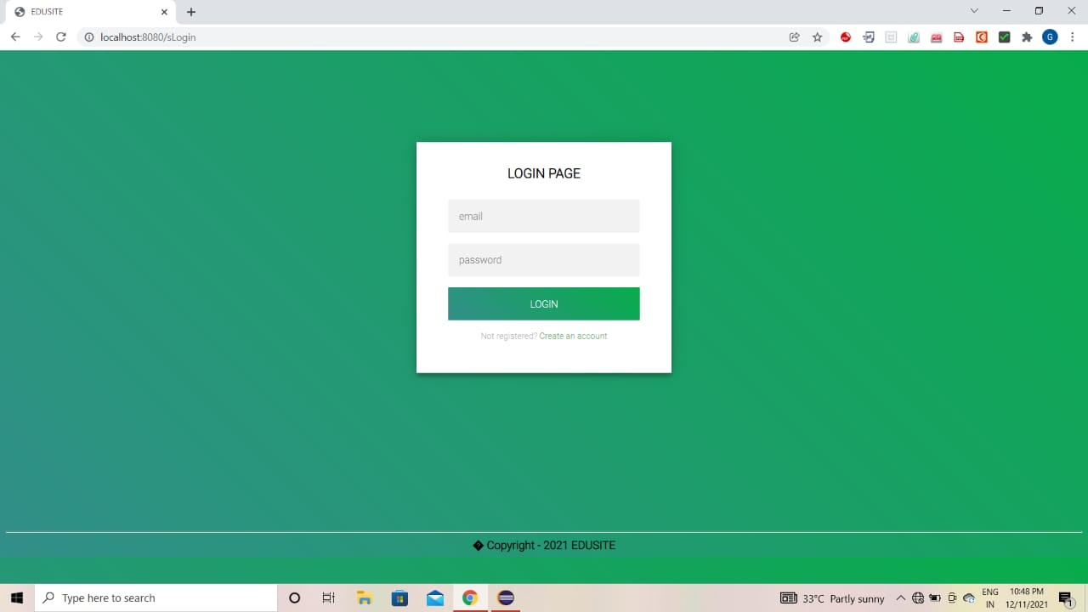

FIG 4: STUDENT REGISTER

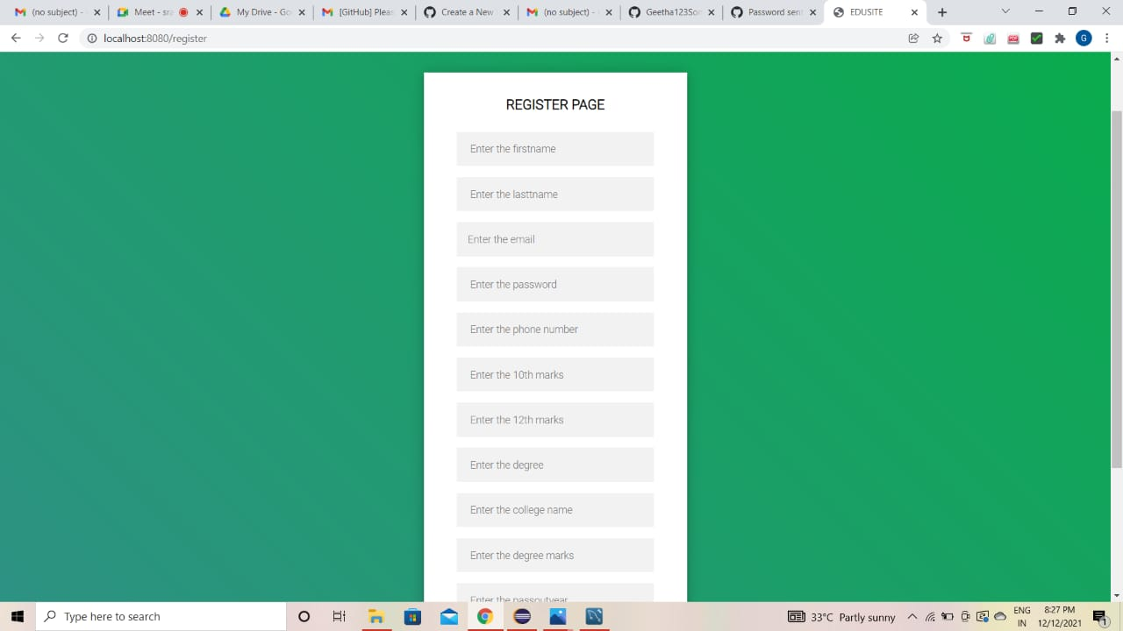

FIG 5: ABMIN DASHBOARD

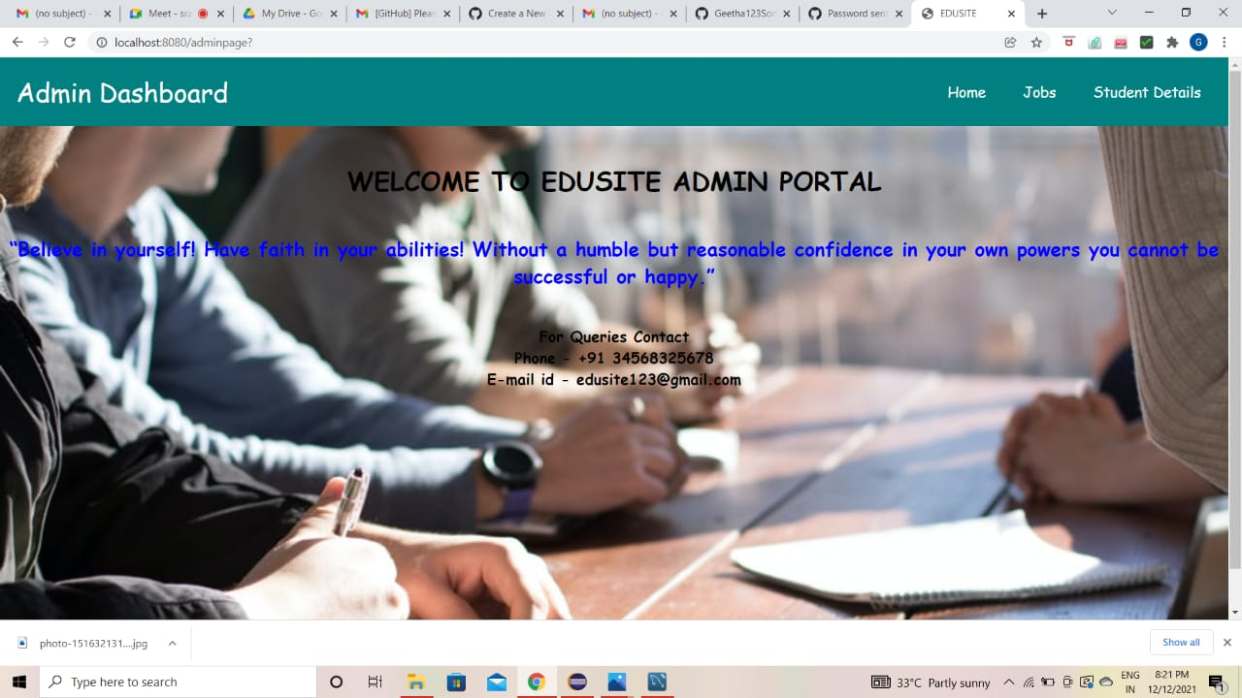

FIG 6: STUDENT DASHBOARD

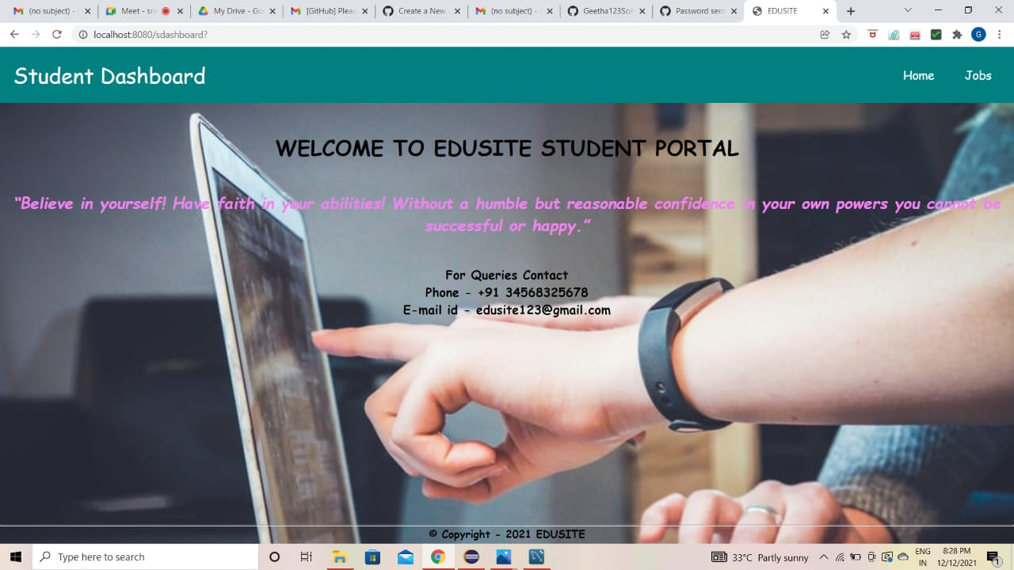

FIG 7: ABMIN JOB PAGE

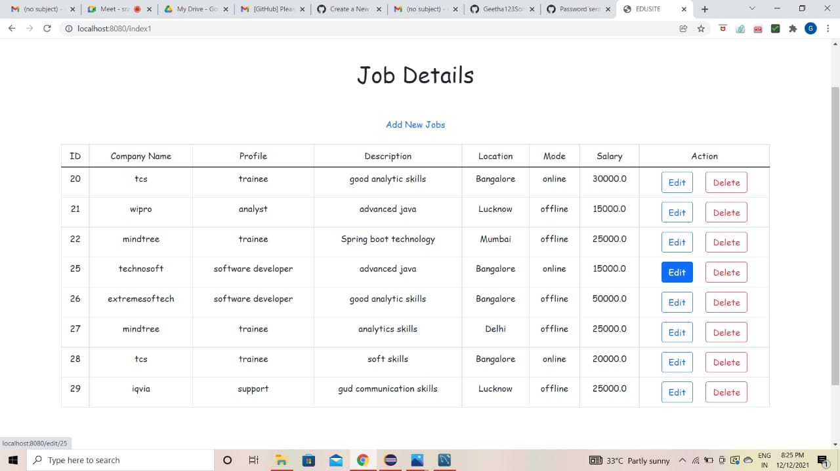

FIG 8: STUDENT JOB PAGE

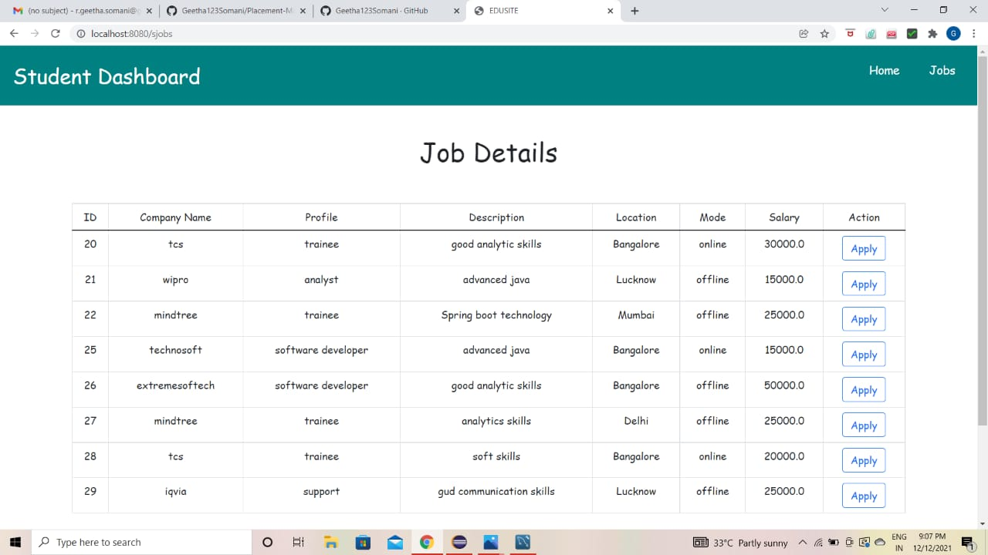

FIG 9: ABMIN ADD JOB PAGE

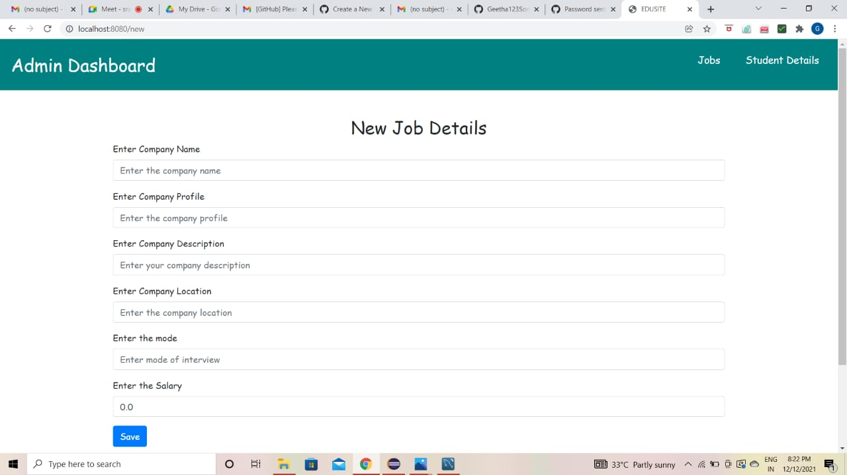

FIG 10: STUDTENT APPLY JOB PAGE

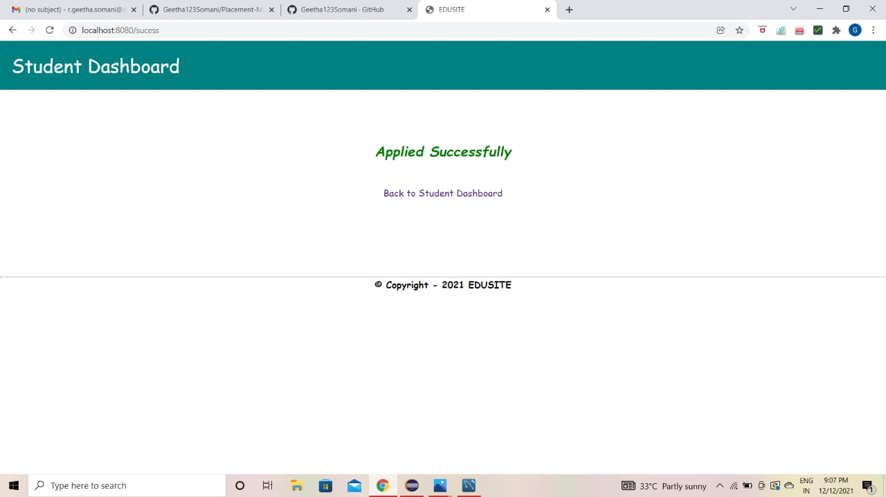

# CONCLUSION

In the existing system maximum work goes manually and it is error prone system, takes time for any changes in the system. The big problem is the searching of the student data and also no any notification method available for giving information to student expect the notice board. The proposed online placement management system gives the automation in all the process like registration, updating, searching.

It provides the detail solution to the existing system problem.

# THANK YOU